

**Teaching Growth Mindset in Schools: Mindset Matters**

**2018 Presentation by Lisa King**

**Website:** [**www.lisakingcounselor.com**](http://www.lisakingcounselor.com) **Email:** [**lisaking4@yahoo.com**](mailto:lisaking4@yahoo.com)

**Twitter: @Lkingcounselor**

|  |  |
| --- | --- |
| ***Topic*** | ***For each topic, use the space below to jot down thoughts on how you can implement these concepts into your lessons/programs.*** |
| **Mindfulness** |  |
| **Identify Brain Basics** |  |
| **Not Yet is OK** |  |
| **Determination**  **and Grit** |  |
| **Self-Talk** |  |
| **Everyone is Unique** |  |
| **Teach What You Know** |  |

**SUCCESS= ___% INTELLIGENCE + ___% EFFORT ?**

**Videos of Interest:** Many of these are hyperlinked on the Growth Mindset Resource page on lisakingcounselor.com

* Carol Dweck’s TED TALK
* www.Trainugly.com
* You Tube: Why Aren’t We Teaching You Mindfulness AnneMarie Rossi
* You Tube: Sentis Neuroplasticity
* You Tube: Carol Dweck A Study on Praise and Mindsets
* You Tube: Why Do we Lose Control of Our Emotions
* You Tube: Animated Core Message GRIT
* You Tube: What Learning Looks Like (Clean)
* You Tube: Japanese Slippery Stairs Game Show Hilarious



**Game-ifying to teach growth mindset:**

The Power of Yet, Grit, and Mindfulness

**Games:**

1. **I’m going to the moon**
2. **Whoops Johnny**
3. **I can do the pencil dance**
4. **10 parts spelled with three letters**

**Activities:**

1. **Pipe Cleaner Challenge (Mindset Matters)**
2. **Craft Stick Challenge (TPT: Playdough to Plato)**
3. **Folded Paper Activity :** [**http://blog.classcreator.io/teaching-kids-to-struggle-growthmindset/**](http://blog.classcreator.io/teaching-kids-to-struggle-growthmindset/)

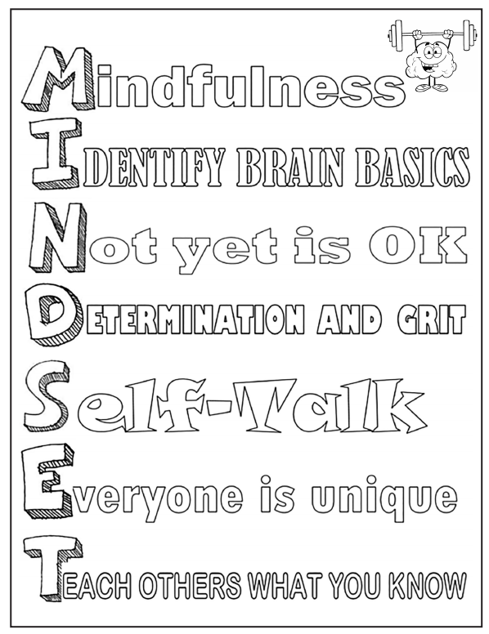

**WOOP!!**

**See characterlab.org for details and supplemental worksheets and lessons on “woop”.**

**Wish**

**Outcome**

**Obstacle**

**Plan**