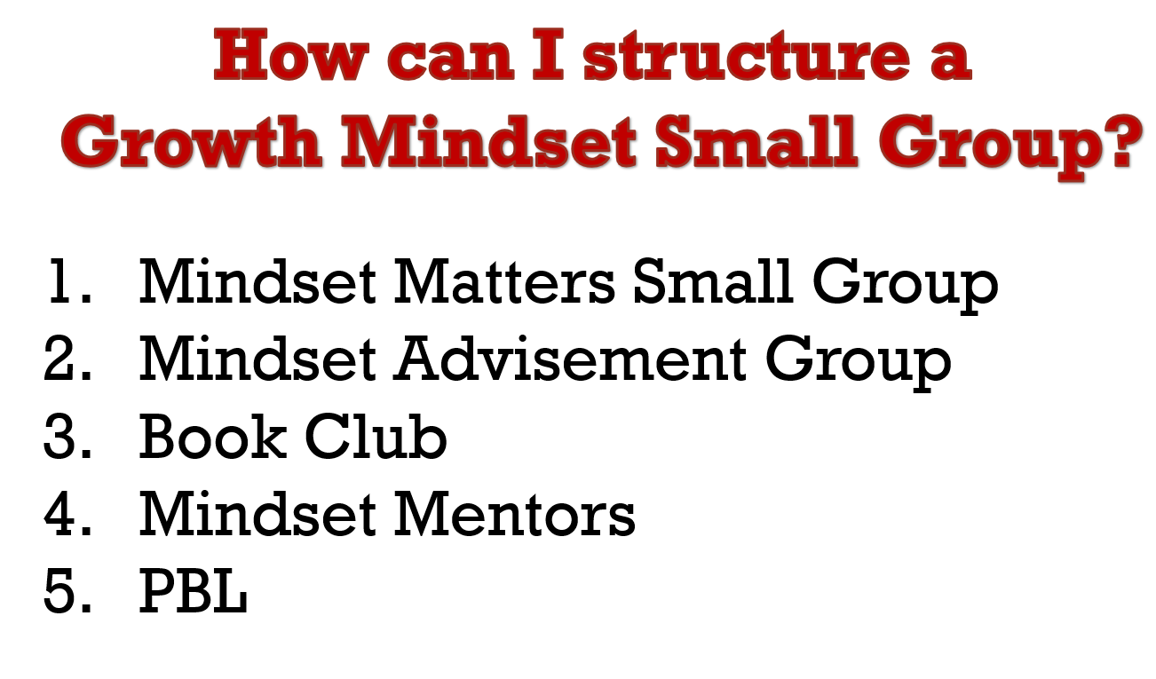
Not Yet Games:
Twitter: @Lkingcounselor Email: lisaking4@yahoo.com
- Mindset Matters: SMALL GROUP OUTLINE SAMPLE
 | activity |  | materials
session 1  date | Introductions. Review Group Rules  Do an Icebreaker  Have students complete Pre Group Survey |  | See pre post survey, pg. 29
session 2  date | MINDFULNESS  Watch video and do lesson that goes along with creating Mindful Minute Jars |  | See page 55-56 for lesson
Session 3  date | Continue decorating Mindful Minute Jars |  | Send letter to parents on page 57
session 4  date: | IDENTIFY BRAIN BASICS  Brain Connections A Yummy Lesson |  | Lesson on page 68-69  Peel and Pull Licorice
session 5  date | NOT YET  Mindset Chant  Review about Brain Basics |  | Not Yet Games:  - I’m going the moon  - Pencil Dance  - Tribonds
session 6  date |  | Determination  Paper Folding  Stamina Discussion | Paper Folding activity  http://blog.classcreator.io/teaching-kids-to-struggle-growthmindset/
session 7  date | Self –Talk |  | Lesson on page 129-131  Seeing the Rainbow in the Rainstorm
Session 9  date | Everyone is Unique |  | Unique Bingo game cards on page 144
session 8  date | Teach others what you know.  Post Survey |  | Questions for “Walk-About” on lanyards, post survey page 157.
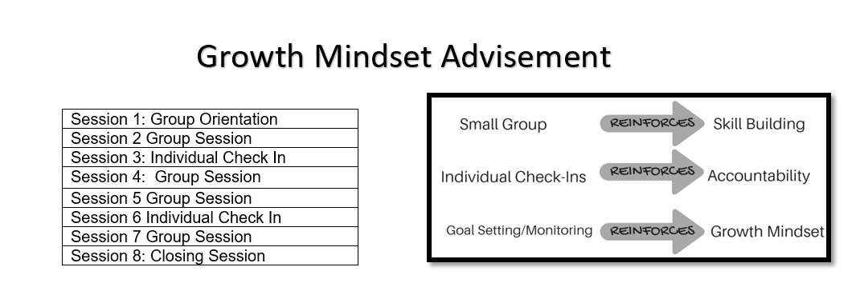
2.

Mindset Survey
Can be used for Pre/Post Assessment
 | Strongly  Agree | Agree | Not Sure | Disagree | Strongly Disagree
1. He/she is determined and has a “I won’t give up” work ethic. | 5 | 4 | 3 | 2 | 1
2. He/she handles it appropriately if he/she makes mistakes. | 5 | 4 | 3 | 2 | 1
3. He/she can calm down if angry. | 5 | 4 | 3 | 2 | 1
4. He/she has a good attitude about school. | 5 | 4 | 3 | 2 | 1
5. He/she seems to have friends. | 5 | 4 | 3 | 2 | 1
6. He/she has positive self-esteem | 5 | 4 | 3 | 2 | 1
7. He/she has good study skills. | 5 | 4 | 3 | 2 | 1
Student Name__________________________________ Date___________
Directions: Answer on a scale of 1-5 how you would rate this student on the following statement.

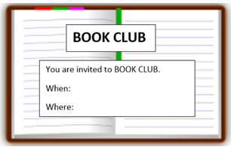
3. MINDSET MATTERS BIBLIOTHERAPY LIST

Mindfulness
- What Does It Mean to Be Present? By Rana DiOrio
- Charlotte and the Quiet Place by Deborah Sosin
- Puppy Mind by Andrew Jordan Nance
- The Lemonade Hurricane: A Story of Mindfulness and Meditation by Licia Morelli

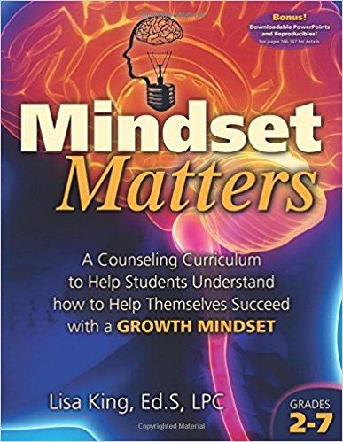
Identify Brain Basics
- Your Fantastic Elastic Brain by Joann Deak
- Think, Think, Think: Learning About Your Brain by Pamela Hill Nettleton
- Young Genius: Brains by Kate Lennard
- Bubble Gum Brain by Julia Cook

Not Yet is OK
- Everyone Can Learn to Ride a Bicycle by Chris Raschka
- Leo the Late Bloomer by Robert Kraus
- Thanks for the Feedback (I Think) by Julia Cook
Available at the bookstore vendor here or on amazon.com
- Beautiful Oops by Barney Salzberg

Determination and Grit
- Emmanuel's Dream: The True Story of Emmanuel Ofosu Yeboah
- Bounce Back! A Book About Resilience by Cheri J. Meiners M.Ed.
- Wilma Unlimited by Kathleen Krull
- Winner Never Quit by Mia Hamm

Self-Talk
- Carla’s Sandwich by Debbie Herman
- It’s Tough to Lose your Balloon by Jarrett J. Krosoczka
- One of Those Days by Amy Krouse Rosenthal

Everyone is Unique
- Only One You by Linda Karanz
- It’s OK to be Different by Todd Parr
- Back to Front and Upside Down by Claire Alexander

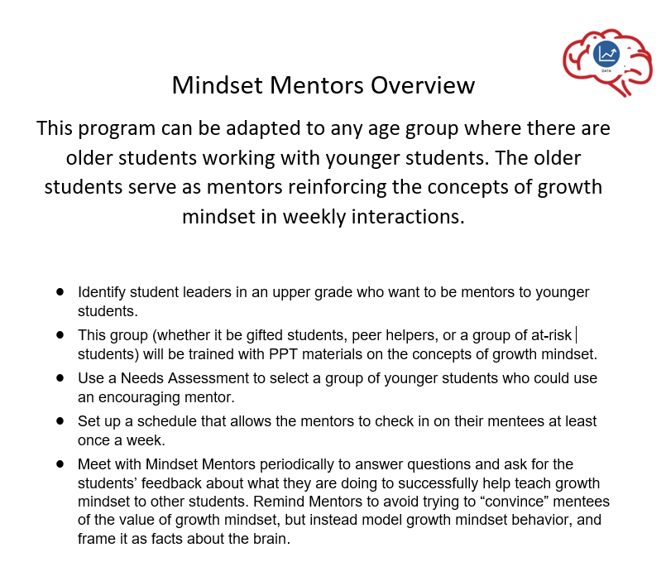
4.

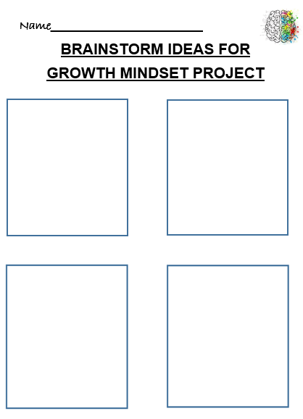
5. Project Based Learning

Projects can include:
Videos, PPTs, Song, Presentation, Artwork, Poster, Skit, Informational Paragraphs

