

**Mindset Matters: Teaching Growth Mindset in Schools**

**Presentation by Lisa King**

**Website:** [**www.lisakingcounselor.com**](http://www.lisakingcounselor.com) **Email:** [**lisaking4@yahoo.com**](mailto:lisaking4@yahoo.com)

**Twitter: @Lkingcounselor**

|  |  |
| --- | --- |
| ***Topic*** | ***For each topic, use the space below to jot down thoughts on how you can implement these concepts into your lessons/programs.*** |
| **Mindfulness** |  |
| **Identify Brain Basics** |  |
| **Not Yet is OK** |  |
| **Determination**  **and Grit** |  |
| **Self-Talk** |  |
| **Everyone is Unique** |  |
| **Teach What You Know** |  |

**SUCCESS= ___% INTELLIGENCE + ___% EFFORT ?**

**Mindfulness**

MINDSET MATTERS SUPPLEMENTAL BIBLIOTHERAPY LIST

* What Does It Mean to Be Present? By Rana DiOrio
* Charlotte and the Quiet Place by Deborah Sosin
* Puppy Mind by Andrew Jordan Nance
* The Lemonade Hurricane: A Story of Mindfulness and Meditation by Licia Morelli

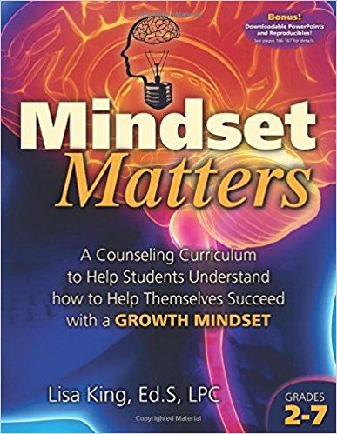

**Identify Brain Basics**

* Your Fantastic Elastic Brain by Joann Deak
* Think, Think, Think: Learning About Your Brain by [Pamela Hill Nettleton](http://www.amazon.com/Pamela-Hill-Nettleton/e/B001IZV5XM/ref=dp_byline_cont_book_1)
* Young Genius: Brains by Kate Lennard
* Bubble Gum Brain by Julia Cook

**Not Yet is OK**

* [Everyone Can Learn to Ride a Bicycle](https://www.amazon.com/gp/product/0375870075/ref=ox_sc_sfl_title_4?ie=UTF8&psc=1&smid=ATVPDKIKX0DER)by Chris Raschka
* Leo the Late Bloomer by Robert Kraus
* Thanks for the Feedback (I Think) by Julia Cook

**Available at the bookstore vendor here or on amazon.com**

* Beautiful Oops by Barney Salzberg

**Determination and Grit**

* Grit & Bear It! By [MS Zentic](http://www.amazon.com/s/ref=dp_byline_sr_book_2?ie=UTF8&text=MS+Zentic&search-alias=books&field-author=MS+Zentic&sort=relevancerank)
* [Bounce Back! A Book About Resilience](https://www.amazon.com/gp/product/1575424592/ref=ox_sc_sfl_title_4?ie=UTF8&psc=1&smid=ATVPDKIKX0DER) by Cheri J. Meiners M.Ed.
* Wilma Unlimited by Kathleen Krull
* Winner Never Quit by Mia Hamm

**Self-Talk**

* Carla’s Sandwich by Debbie Herman
* It’s Tough to Lose your Balloon by Jarrett J. Krosoczka
* One of Those Days by Amy Krouse Rosenthal

**Everyone is Unique**

* Only One You by Linda Karanz
* It’s OK to be Different by Todd Parr
* Back to Front and Upside Down by Claire Alexander

**Videos of Interest:** Many of these are hyperlinked on the Growth Mindset Resource page on lisakingcounselor.com

* Carol Dweck’s TED TALK
* www.Trainugly.com
* You Tube: Why Aren’t We Teaching You Mindfulness AnneMarie Rossi
* You Tube: Sentis Neuroplasticity
* You Tube: Carol Dweck A Study on Praise and Mindsets
* You Tube: Lori Cross Brain Model
* You Tube: Animate Core Message GRIT

