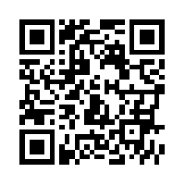

Scan this QR Code to learn more about the School Counseling Program here at our school.

Don’t forget to change this the QR code for your website. Click here to do it at <http://www.qr-code-generator.com/>

**Meet Your School Counselors!**

Let us know how we can help you.

Insert photo of your school’s counselors here. ☺