How are you doing?
Name: ______________________ Teacher: _____________________
I have made some friends.
I know my way around the building.
I like my class.
I think this year is going to be ok.
I might need some help from Ms. King (me).
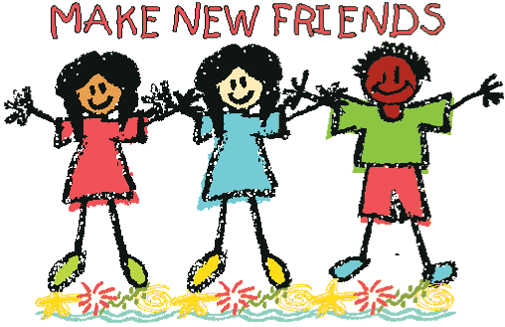
You are now a
Blackwell Bulldog!

