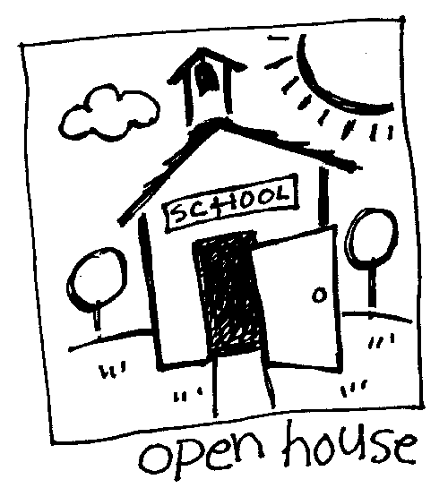

DATE: August 2015

TO: Blackwell Elementary School Teachers

FROM: Lisa King and Shannon Scepaniak

RE: 2015-16 Needs Assessment and times for Classroom Lessons

In our role as school counselors we are responsible for delivering a core counseling curriculum in the areas of personal/social development, academic success, and career awareness; run small group counseling sessions in response to identified needs ; and provide individual planning and counseling for students. Here is a needs assessment based on identified needs from the past several years as well as the National School Counseling Standards. Please choose the topics in each domain that you feel your classroom is in most need of during the school year so we know what areas you would like for us to focus.

If you have any questions, please do not hesitate to e-mail or talk to either of us, and we would be happy to answer any questions you may have.

Lisa King, Ed.S and Shannon Scepaniak, M.Ed
School Counselors

Please designate your top three choices of times for guidance: thirty minute slots (i.e. 10:30- 11:00). If there is a specific day you prefer, please designate that as well.

TEACHER NAME ___________________________________

1st choice__________________________

2nd choice__________________________

3rd choice__________________________

2015-2016 Blackwell ES
Needs Assessment
Grades K-5 Grade Level_______________________

These are the three School Counseling Domains of the National School Counseling Standards of the American School Counseling Association. Below are suggested topics under each domain based on the standards. Please make sure that your grade level is on the needs assessment.

Choose 5 Choose 4 Choose 3
Personal/Social Development | Academic Development | Career Development  (Career Awareness activities, etc.)
☐ Conflict Resolution | ☐ Accepting mistakes | ☐ Importance of Planning
☐ Personal Space | ☐ Time management | ☐ Develop an awareness of personal abilities, skills, interests, and motivators.
☐ Understanding Diversity | ☐ Asking for help | ☐ Importance of Character in the World of Work
☐ Manners | ☐ Learning Styles | ☐ Learning to use the Internet to access career planning information
☐ Making & Keeping Friends | ☐ Perseverance | ☐ Ability to identify traditional and nontraditional careers
☐ Communication Skills (speaking, listening, and nonverbal behavior) | ☐ College Readiness skills (age appropriate) | ☐ Understanding the similarities between school and the workplace
☐ Consequences of decisions and choices. | ☐ Goal Setting
☐ Empathy/Compassion | ☐ Understanding the relationship between classroom performance & school success
☐ Stress/Anger Management | ☐ Understand the relationship between school success & future opportunities
☐ Self-Control | ☐ Responsibility
☐ Peer Pressure | ☐ Work Ethic
☐ Problem Solving Model
☐ Teamwork/Cooperation

