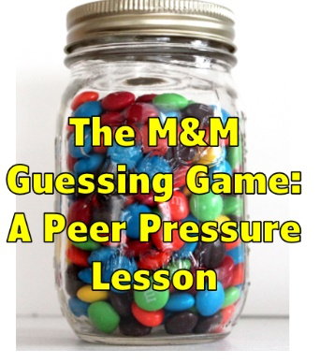
Classroom Core Curriculum Lesson
Created by: Lisa King

Grade Level: 4th through 8th (or even high school)
Time Required: 30-45 minutes

Essential Questions: -Do friends influence my decision making?
-What are examples of positive and negative peer pressure?

Materials/Resources :Jar full of M&M’s (you need to know how many are in the jar), Signs that say agree/disagree/not sure, small packs of m and m’s or other prize, attached worksheet (1/2 sheets)

Lesson Activity:
- Ask students to think about this question. “Do your friends influence you to make decisions?” Have students fill out the Likert scale at the top of the page (marked A). Remind students that they do not have their names on the paper, that you are curious what their thoughts are.

- Introduce subject of today’s lesson is peer pressure. Ask students if they know what peer pressure is? Have students describe positive and negative peer pressure.

- Say, “OK, let’s take a break and play a game. This is the M&M guessing game. Let’s use the piece of paper that I passed out. You need pencil. You will be guessing how many M&M’s are in this jar. The winner gets a prize.”

- For #1 counselor says “Write down how many M&M’s you think there are”
- For #2 counselor says, “Get in a group of 4 people and decide on 1 number for you all to agree on of how many M&M’s you think there are in the jar.” All answers for your group must be the same.
- For #3 counselor says “Now you decide on your own how many M & M’s you really think are in the jar. Don’t let other see your answer. Remember this is the final answer and this answer will determine who wins a prize”

Find the winner. Give prize to person who got closest on #3.

- Now tell the class, that this activity connects to the lesson that we started out discussing and proves, that even if you aren’t aware of it, your peers influence you.

Possible questions to discuss and think about:
How many people have the same guesses for #1 and #3? Did your peers influence you to change your mind?
Did any of you convince someone else to change their mind to do what you thought was best? (You peer pressured them! )
Think about how someone might convince you their way is the best. (logic, persistence, intimidation)

- Tell students that it’s time to play another game. This time, I want you to be aware of peer pressure. (Think about the tug in your belly you get, when your friend answers one way and you want to go to the corner your friend goes to even if it isn’t your answer).

- Counselors will put the Agree/Don’t Agree/ Not Sure signs in three corners of the room. Tell students that they should walk to the corner of what describes them.
- I like broccoli.
- I used to watch My Little Pony/Bob the Builder (or Barney something that might be slightly uncool)
- I like school.
- I think teens should be able to drink alcohol.
- I get nervous about statewide testing.

- Briefly ask for reactions of what the students discovered about how their friends influenced which corner they went to.
- Watch video called “Summer Bordeom” about kids bored in summer tempted by peer pressure to try cigarettes www.youtube.com/watch?v=olUNPAuMXCk (4 minutes)

Assessment:
Have students look back at their paper and at the bottom of the page answer the question marked B, for what you now believe: Do your friends influence you to make decisions?
Counselor can compare the class average of Question A vs, Question B to see how attitudes changed.

Optional supplements for this lesson or next lesson:

- Review Refusal Skills using Sharon Scott’s How to Say No and Keep Your Friends (1997). This book is recommended for ages 12 and up reading level but the strategies are appropriate for review in 4th and 5th grade.

- Tell kids to put their heads down and answer the following questions to give you a better sense of what pressures kids their age are dealing with. Have kids put heads down, close their eyes and answer questions.

Do you know kids your age who have:
    - -tried cigarettes
    - -alcohol
    - -Marijuana
    - -shoplifted

- Do your friends influence you to make decisions?
1------------------2-----------------3-----------------4--------------5
Never a little sometimes a lot always

Game
1.

2.

3.

- Do your friends influence you to make decisions?
1------------------2-----------------3-----------------4--------------5
Never a little sometimes a lot always

------------------------------------------

- Do your friends influence you to make decisions?
1------------------2-----------------3-----------------4--------------5
Never a little sometimes a lot always

Game
1.

2.

3.

- Do your friends influence you to make decisions?
1------------------2-----------------3-----------------4--------------5
Never a little sometimes a lot always

