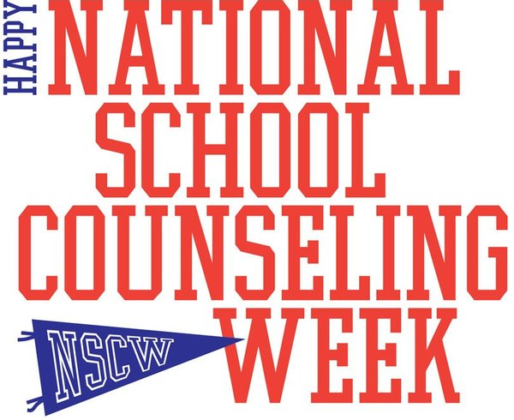

In 2006, Congress declared the first week of February as National School Counseling Week. The purpose of NSCW is to highlight the impact school counselors can have in helping students achieve success and plan for their future. In honor of National School Counseling Week, we wanted to share some facts you may not know about school counselors.

Did you know?

School counselors have standards to teach too! Our national standards are developed through the American School Counselor Association (ASCA). Our standards are split into three domains: academic, career, and social/emotional.

We feel so lucky to work with an amazing and positive staff at Blackwell! Our goal is to help students reach their full potential through work with individual students, groups, classroom lessons, and collaboration with parents and staff to better understand and meet the needs of our school!

Thank you for your support, hard work, and dedication to our students!

