Name ___________________

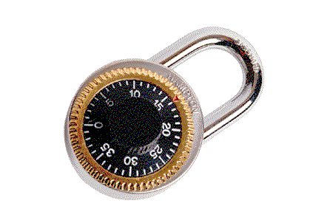

6th grade... HERE WE COME!
J | D | E | Z | C | Q | I | S | D | A | H | S | R | W | S
C | F | E | A | X | G | N | E | R | J | G | B | K | E | A
K | A | I | T | Y | W | T | E | O | E | Q | E | U | Y | S
X | Z | B | F | E | E | R | H | N | R | K | Q | N | Z | F
A | L | A | L | N | R | A | N | L | U | I | C | A | D | H
V | S | J | T | J | P | M | M | T | L | D | U | O | B | A
D | D | I | P | K | Y | U | I | C | J | E | A | F | L | J
P | O | H | H | T | A | R | O | N | I | K | U | A | Q | X
N | S | R | E | H | C | A | E | T | A | N | N | P | W | S
V | E | K | C | K | D | L | S | S | D | T | I | C | B | D
R | E | S | P | O | N | S | I | B | I | L | I | T | Y | N
G | R | A | D | E | S | X | U | P | B | U | A | O | G | E
N | B | F | O | H | C | E | K | N | I | N | F | J | N | I
R | Y | G | W | M | T | K | A | U | Z | C | N | I | Z | R
H | J | A | O | W | Q | G | A | H | L | H | X | U | X | F

AGENDA | CLIQUES | DETENTION | TEACHERS
DETERMINATION | FRIENDS | FUN | RESPONSIBILITY
GRADES | INTRAMURALS | LOCKERS | LUNCH

