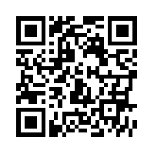
Scan this QR Code to learn more about the School Counseling Program at Blackwell Elementary.

Meet Blackwell’s
School Counselors!

Let us know how we can help you.

