Fill out the information below:
Name____________________________________________________________

Address ___________________________________________________________
____________________________________________________________
Parent/Guardian’s Phone Number:
_______________________________________________
_______________________________________________
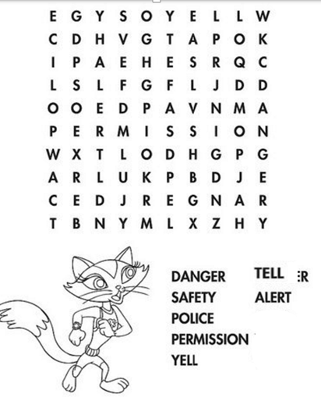
Here are 4 trusted adults I could talk to if I have a safety situation I need to talk about:

1.

2.

3.

4.

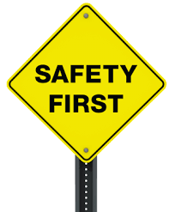

Parents: In our lesson today we reviewed different safety rules. Ask your child what they learned and review other safety rules your family might have.
Ms. King, school counselor

