Mrs. Shackelford is our principal. Ms. Roach is our assistant principal.
They make sure that our school is a great place to learn.


Our front office staff will help you with any questions you might have. Ms. Tina, Ms. Irma, & Ms. Lucretia are always here to help.


Nurse Sheri France is the school nurse. She gives medication and helps students who are sick or injured. Ms. Sheri wants you to feel well where you can be in the classroom to learn.
Mrs. Donn is your Music teacher. In Music, you will sing and play instruments.

Ms. McKeehan is our Art teacher. You will be learning about different kinds of art and creating your own masterpieces in this class.
Coach Ransom and Mrs. Spence are your P.E. teachers. In P.E. you will enjoy activity and learn about being fit and healthy.


Mrs. Fowler and Ms. Toni are the adults that will help you in the media center. You will be able to check out interesting books from our school library and these ladies can tell you more about how our library works and how you can check out those books.
Mrs. Scepaniak and Ms. King are our school counselors. They visit classrooms to teach lessons that will help you be the best you can be in life and get along well with others. If you have a problem of any kind, you can trust your counselors to help.
.

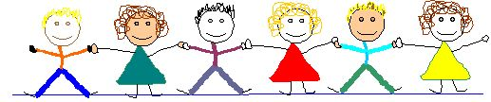


Blackwell has a great After School Program. This program is opened until 6pm. There are many enrichment programs and clubs available after school as well.
We are glad that you have joined the Blackwell Elementary family. We hope you have a great school year!




WE
WE ARE BLACKWELL PROUD!





WELCOME TO
BLACKWELL ELEMENTARY SCHOOL

