Blackwell’s Counselors are here for YOU!

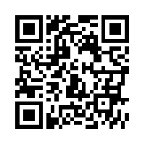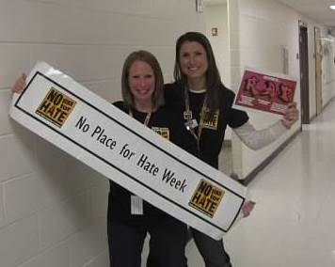

Scan this QR code to see our blog.