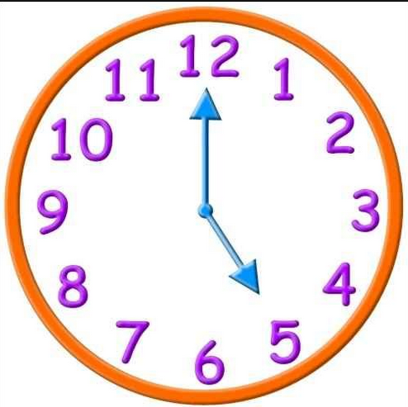
Request for Counselor Lesson Times with Ms. King

Please take a minute to fill out this form to give me an idea of what time blocks would be good for me to come on a regular basis. I’ll do my best to accommodate everyone, but early birds are more likely to get their first choice. Of course, you can change your time as the need arises during the year. Thank you!

Grade ____________ Teacher name _________________________

These are my top three choices of times for guidance: thirty minute slots (i.e. 10:30- 11:00).

1st choice__________________________

2nd choice__________________________

3rd choice__________________________

Please return to Ms. King’s mailbox or via email as soon as possible.

