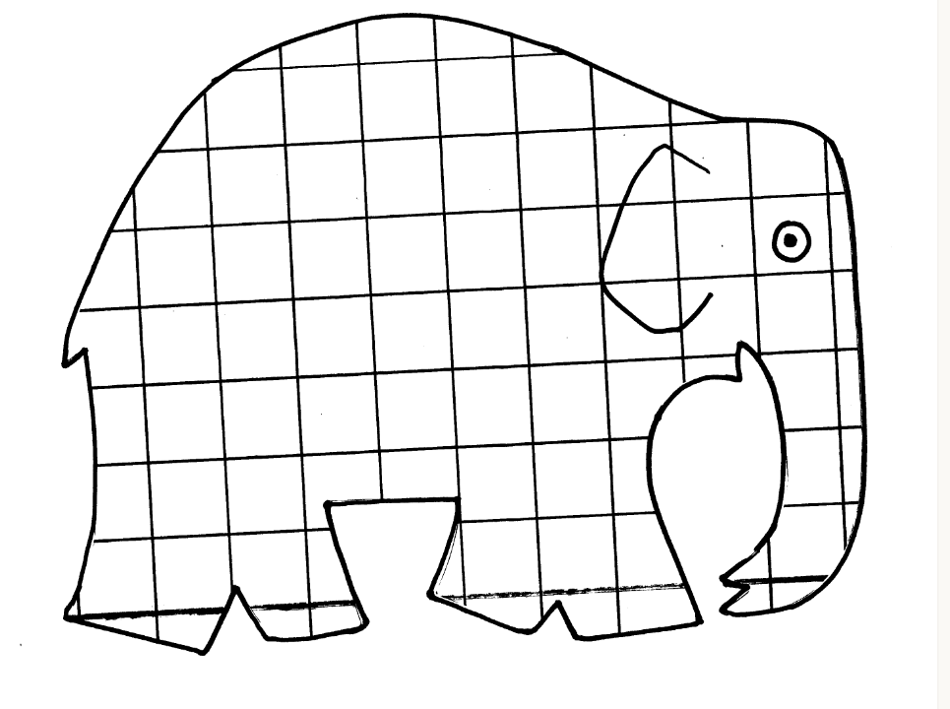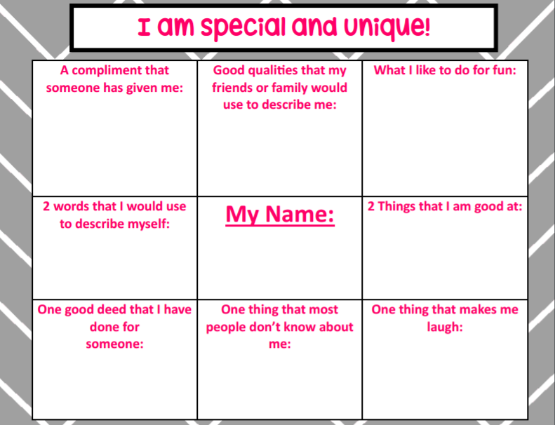

**My favorite school subject:**

**People say that I look like:**

**My eyes are:**

**My hair is:**

In today’s counseling lesson we read Elmer by David McKee. In honor of Exceptional Children’s Week we discussed the importance of understanding how we are all unique.