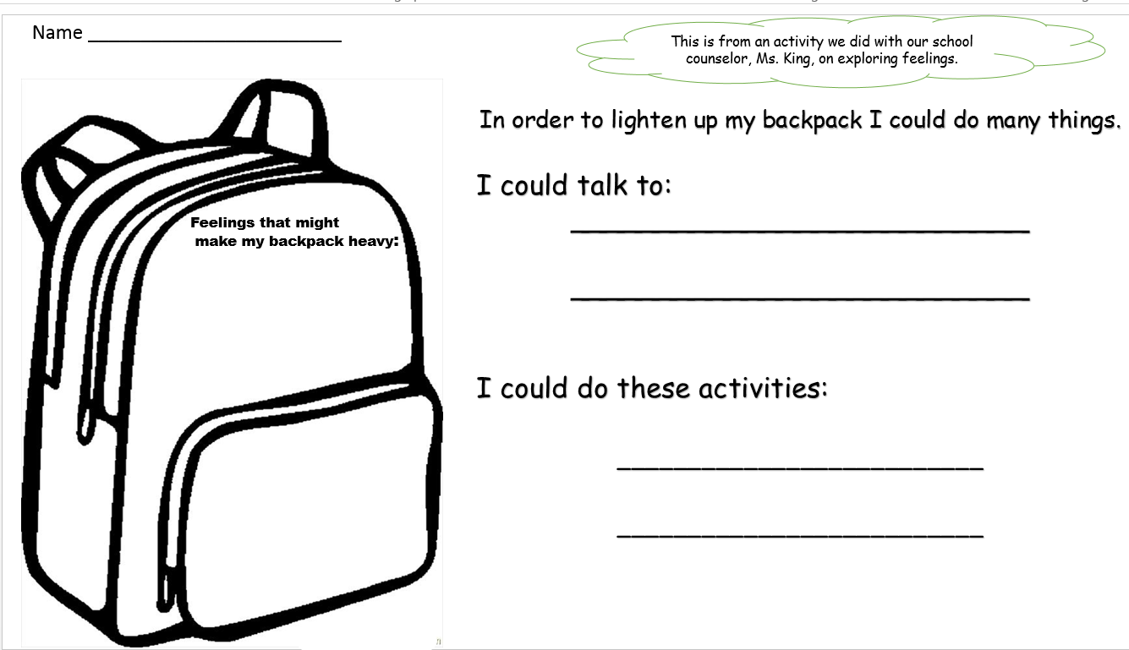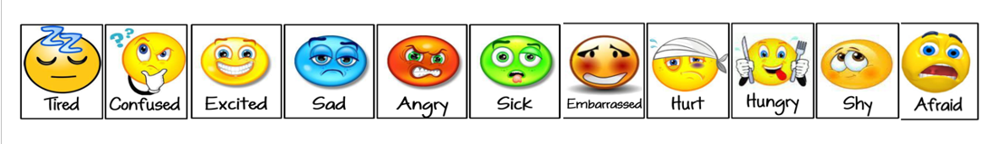

This is from an activity we did with our school counselor, Ms. King, on exploring feelings.

Name _________________________________